**Architecture of Kubernetes**

A Kubernetes cluster is a form of Kubernetes deployment architecture. Basic Kubernetes architecture exists in two parts: the control plane and the nodes or compute machines. Each node could be either a physical or virtual machine and is its own Linux environment. Every node also runs pods, which are composed of containers.

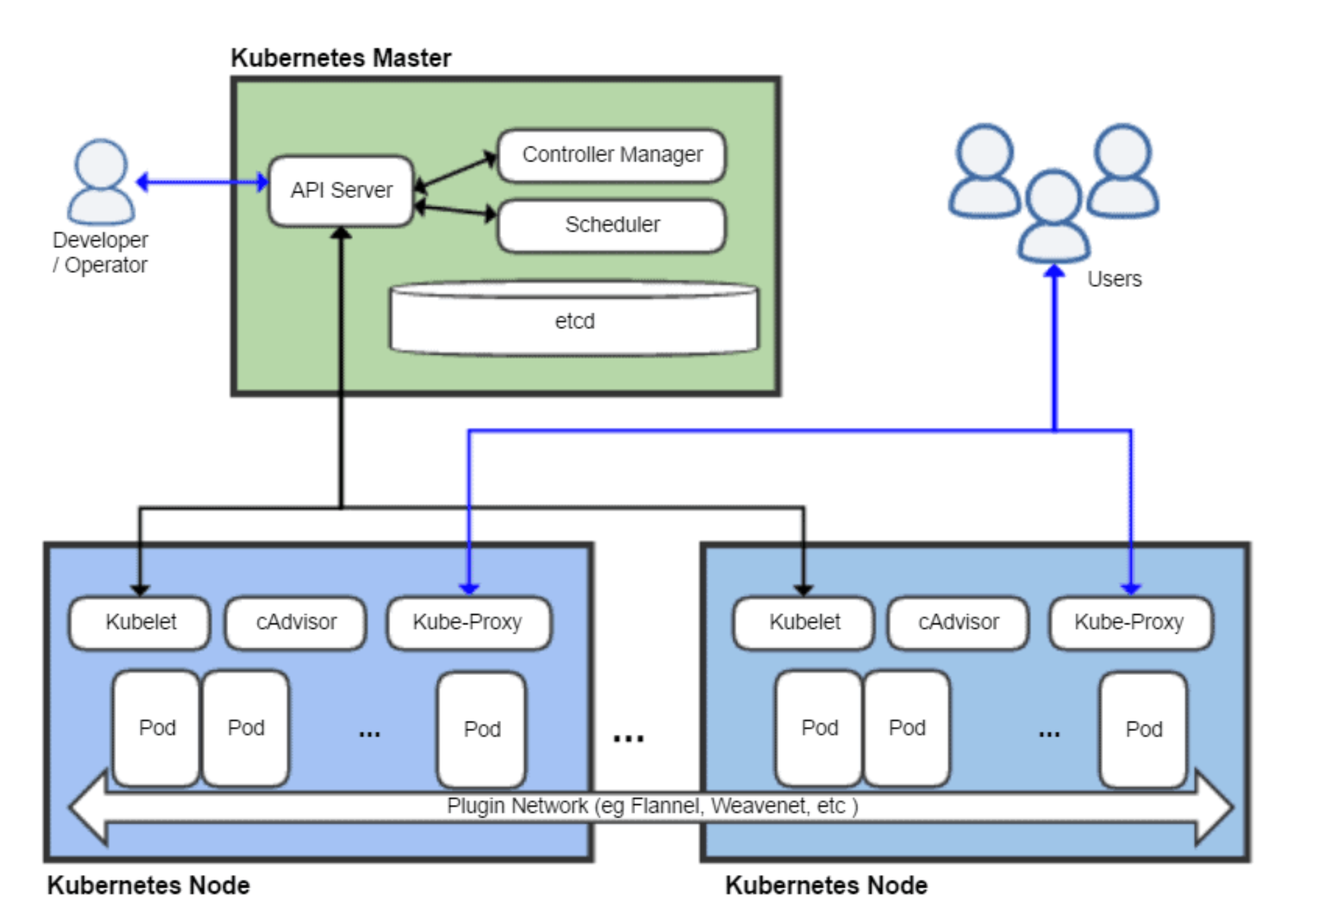

An environment running Kubernetes consists of the following basic components: a control plane (Kubernetes master), a distributed key-value storage system for keeping the cluster state consistent (etcd), and cluster nodes (Kubelets, also called worker nodes or minions).

**Master Components:**

**API Server:**

Facilitates communication between the various components inside & from outside the cluster. Validates, Authenticates and checks authorization of the calls to the cluster. It is the only component that communicate with the etcd.

**Etcd:**

In simple words we can say it’s a DB of the Cluster. Manages the state of the cluster. It stores value in a simple Key value storage. Stores conﬁguration data which can be accessed by the Kubernetes Master's API Server using simple HTTP or JSON API

**Scheduler:**

It decides the best node on which the workload (Pod) should be deployed to and also watches new workloads and assigns nodes to them. Default methodology is to check resource availability on nodes

**Controller Manager:**

It manages Controllers. Runs in loops and tries to matches the current & desired state. Kube-controller-manager implements:

○ node controller ○ endpoints controller ○ Deployment ○ namespace controller etc.

**Components of Nodes:**

**Kubelet:**

The bridge that joins the available CPU, disk, and memory for a node into the large Kubernetes cluster. Communicates with the API server to ﬁnd pods that should be running on its node. Reports back the health of the node & the pods running on it. Manages the health check and restart policy of container.

**Kube-Proxy:**

The network brain of the node. It manages the Routing Table of the node. Every Pod get its unique IP. It Routes traﬃc to actual pod